WEEK 3 -- MP3 AWS Lex V2 & Lambda

3.1. AWS Graph Creator Lambda Function:
tutorial:
https://medium.com/accenture-the-dock/serverless-api-with-aws-and-python-tutorial-3dff032628a7

- 在aws console里面DynamoDB， create table
- 在aws console里面Lambda 服务，create function

import json
import boto3
from collections import deque

dynamodb = boto3.resource('dynamodb')
table = dynamodb.Table('GraphDistances') # 替换为您的表名

def lambda_handler(event, context):
try:
# 解析请求体
body = json.loads(event['body'])
graph_str = body.get('graph')
if not graph_str:
return {
'statusCode': 400,
'body': json.dumps({'error': 'Graph not provided'})
}

# 构建图的邻接表
adjacency = {}
edges = graph_str.split(',')
for edge in edges:
src, dst = edge.split('->')
adjacency.setdefault(src, []).append(dst)

# 计算所有顶点之间的最短距离（BFS）
distances = {}
vertices = set()
for src in adjacency:
vertices.add(src)
for dst in adjacency[src]:
vertices.add(dst)

for vertex in vertices:
distances[vertex] = {}
# BFS 从 vertex 开始
queue = deque()
queue.append((vertex, 0))
visited = set()
while queue:
current, dist = queue.popleft()
if current in visited:
continue
visited.add(current)
distances[vertex][current] = dist
for neighbor in adjacency.get(current, []):
if neighbor not in visited:
queue.append((neighbor, dist + 1))

# 清空 DynamoDB 表
# 修改部分：为 'source' 定义别名 '#s'
scan = table.scan(
ProjectionExpression='#s, destination',
ExpressionAttributeNames={
'#s': 'source'
}
)
with table.batch_writer() as batch:
for item in scan.get('Items', []):
batch.delete_item(
Key={
'source': item['source'],
'destination': item['destination']
}
)

# 将新数据写入 DynamoDB
with table.batch_writer() as batch:
for src in distances:
for dst in distances[src]:
batch.put_item(
Item={
'source': src,
'destination': dst,
'distance': distances[src][dst]
}
)

return {
'statusCode': 200,
'body': json.dumps({'message': 'Graph processed and stored successfully'})
}

except Exception as e:
return {
'statusCode': 500,
'body': json.dumps({'error': str(e)})
}

- 配置 API Gateway
Create api, regional
Create resource
在resource下面Create method，连上lamda function
Deploy api，加上stage
记录invoke URL

- 测试API
使用 Python 的 requests 库编写一个测试脚本
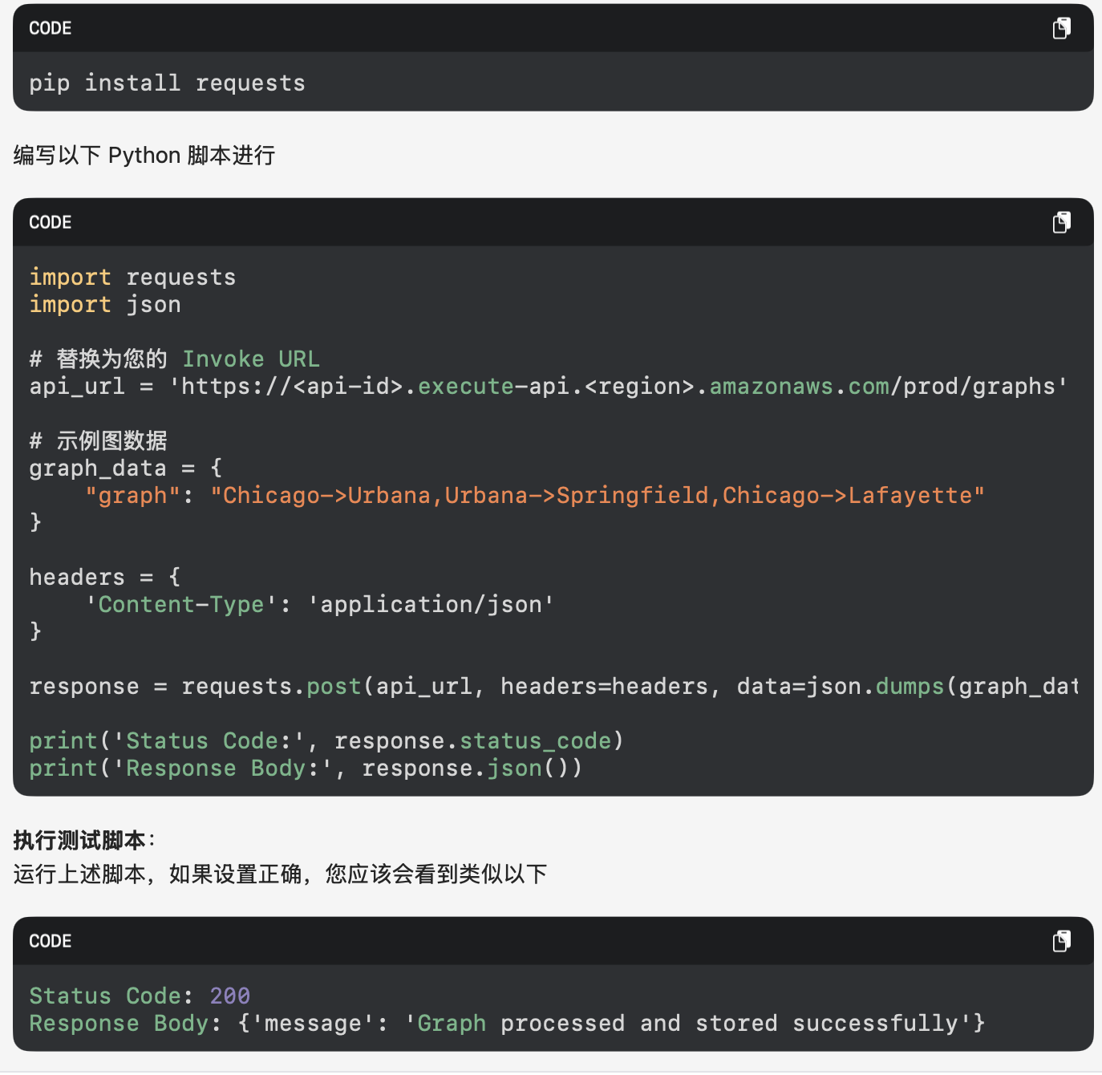

- 看到dynamoDB里面已经有了记录

Check out the code examples of AWS SDK for Python (Boto3) to create, configure, and manage AWS services, you will use this library in this and other MPs.

3.2 AWS Lex:

- 在aws lex 里面 create bot，language选好，intent和slots里面怎么选好，After your intent is saved, choose Build，test。可以有好多个intent

参考这个文档
https://aws.amazon.com/blogs/machine-learning/creating-a-bankingbot-on-amazon-lex-v2-console-with-support-for-english-and-spanish/

3.3 Lex with Lambda:

- Creating a Lambda function，deploy
import json
import boto3

dynamodb = boto3.resource('dynamodb')
table = dynamodb.Table('GraphDistances') # 替换为您的 DynamoDB 表名

def lambda_handler(event, context):
try:
# 提取槽值
intent = event['sessionState']['intent']
source = intent['slots']['Source']['value']['interpretedValue']
destination = intent['slots']['Destination']['value']['interpretedValue']

# 查询 DynamoDB 获取距离
response = table.get_item(
Key={
'source': source,
'destination': destination
}
)

# 如果找不到直接反向查询
if 'Item' not in response:
response = table.get_item(
Key={
'source': destination,
'destination': source
}
)

if 'Item' in response:
distance = response['Item']['distance']
message = distance
else:
message = "Sorry, I don't have the distance information for those cities."

return {
'sessionState': {
'dialogAction': {
'type': 'Close'
},
'intent': {
'name': intent['name'],
'state': 'Fulfilled'
}
},
'messages': [
{
'contentType': 'PlainText',
'content': message
}
]
}

except Exception as e:
return {
'sessionState': {
'dialogAction': {
'type': 'Close'
},
'intent': {
'name': intent['name'],
'state': 'Failed'
}
},
'messages': [
{
'contentType': 'PlainText',
'content': f"An error occurred: {str(e)}"
}
]
}

- 在aws lex 建好的bot，choose aliases，choose language，然后选则source，就是你刚建好的lambda方程。
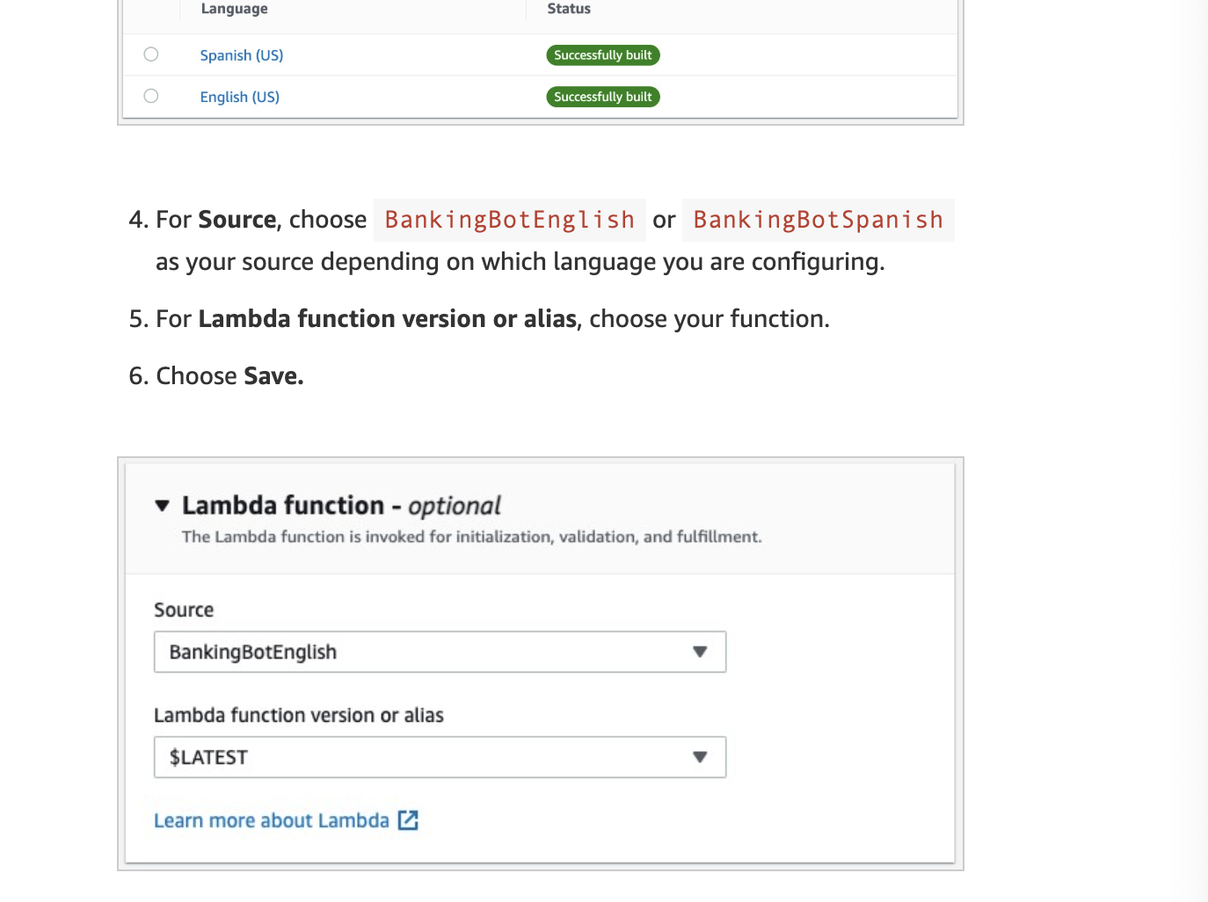

3.4 Deploying Lex:
Using AWS Cognito Identity Pool

Set up Amazon Cognito
Go to identity pool，create identity pool
Guest access
Create a new iam role
Identity pool name
得到Identity pool id
- 到IAM里面的role，找到上面那个role
在permission里面加上
AmazonLexRunBotsOnly
AmazonPollyReadOnlyAccess policies

Test your chatbot on the web
You quickly put together an HTML file that you can use to test your bot. The pool ID is used here to establish an IAM session.
You upload the file so that you can host it on Amazon S3 as a static web site to test your chatbot on the web.

参考这个文档最后部分
https://aws.amazon.com/blogs/machine-learning/greetings-visitor-engage-your-web-users-with-amazon-lex/

